**DAILY ONLINE ACTIVITIES SUMMARY**

|  |  |  |  |  |  |  |  |  |
| --- | --- | --- | --- | --- | --- | --- | --- | --- |
| **Date:** | **20-06-2020** | | | | | **Name:** | **Anix Jugal D’Cunha** | |
| **Sem & Sec** | **8 sem , A sec** | | | | | **USN:** | **4AL16CS013** | |
| **Online Test Summary** | | | | | | | | |
| **Subject** | | **No test was conducted** | | | | | | |
| **Max. Marks** | | **--** | | **Score** | | | **--** | |
| **Certification Course Summary** | | | | | | | | |
| **Course** | **JavaScript Object Oriented Programming** | | | | | | | |
| **Certificate Provider** | | | **Udemy** | | **Duration** | | | **5 hours** |
| **Coding Challenges** | | | | | | | | |
| **Problem Statement:** Find the gravitational force of the distance between the centres of the masses using Python Programming | | | | | | | | |
| **Status: Competed** | | | | | | | | |
| **Uploaded the report in Github** | | | | | **yes** | | | |
| **If yes Repository name** | | | | | **alvas-education-foundation/dcunhaanixjugal** | | | |
| **Uploaded the report in slack** | | | | | **yes** | | | |

Online Test Details: (Attach the snapshot and briefly write the report for the same)

No test was conducted

Certification Course Details: (Attach the snapshot and briefly write the report for the same)

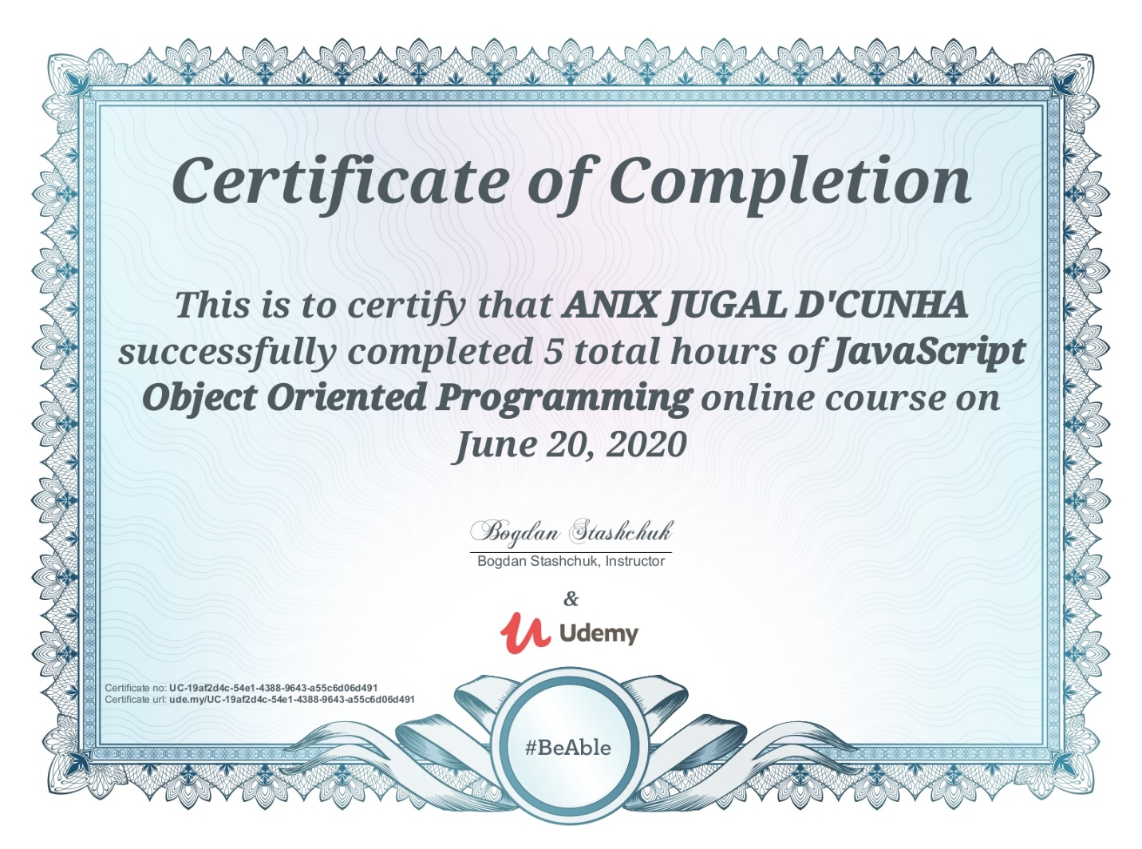

Coding Challenges Details: (Attach the snapshot and briefly write the report for the same)

Program->  Find the gravitational force of the distance between the centres of the masses using Python Programming

Top of Form

Bottom of Form

Top of Form

Bottom of Form

|  |  |
| --- | --- |
|  |  |
|  |  |
|  | m1=float(input("Enter the first mass: ")) |
|  | m2=float(input("Enter the second mass: ")) |
|  | r=float(input("Enter the distance between the centres of the masses: ")) |
|  | G=6.673*(10**-11) |
|  | f=(G*m1*m2)/(r**2) |
|  | print("Hence, the gravitational force is: ",round(f,2),"N") |